Laraib Akhtar
2480151
BSSE 3-B
DSA LAB ASSIGNMENT

Q.no: 1
class DoublyLinkedList {
class Node {
int data;
Node prev, next;
Node(int data) { this.data = data; }
}
Node head, tail;
void insertAtBeginning(int data) {
Node n = new Node(data);
if (head == null) head = tail = n;
else {
n.next = head;
head.prev = n;
head = n;
}
}
void insertAtEnd(int data) {
Node n = new Node(data);
if (tail == null) head = tail = n;
else {
tail.next = n;
n.prev = tail;
tail = n;
}
}
void displayForward() {
Node t = head;
while (t != null) {
System.out.print(t.data + " ");
t = t.next;
}
System.out.println();
}
void displayBackward() {
Node t = tail;
while (t != null) {
System.out.print(t.data + " ");
t = t.prev;
}
System.out.println();
}
void deleteFirst() {
if (head == null) return;
if (head == tail) head = tail = null;
else {
head = head.next;
head.prev = null;
}
}
void deleteLast() {
if (tail == null) return;
if (head == tail) head = tail = null;
else {
tail = tail.prev;
tail.next = null;
}
}
void deleteByValue(int val) {
Node t = head;
while (t != null && t.data != val) t = t.next;
if (t == null) return;
if (t == head) deleteFirst();
else if (t == tail) deleteLast();
else {
t.prev.next = t.next;
t.next.prev = t.prev;
}
}
void findMinMax() {
int min = head.data, max = head.data;
Node t = head;
while (t != null) {
if (t.data < min) min = t.data;
if (t.data > max) max = t.data;
t = t.next;
}
System.out.println("Min = " + min + ", Max = " + max);
}
}

public class Main {
public static void main(String[] args) {
DoublyLinkedList dll = new DoublyLinkedList();
dll.insertAtBeginning(10);
dll.insertAtBeginning(20);
dll.insertAtEnd(30);
dll.insertAtEnd(40);
dll.insertAtEnd(5);
dll.insertAtEnd(50);
dll.displayForward();
dll.displayBackward();
dll.deleteFirst();
dll.deleteLast();
dll.deleteByValue(20);
dll.displayForward();
dll.findMinMax();
}
}

Output:
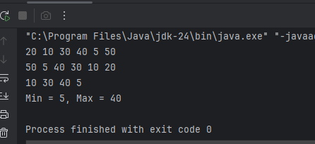

Q.no: 2a
class ArrayQueue {
int[] arr;
int front = 0, rear = -1, size;
ArrayQueue(int capacity) {
size = capacity;
arr = new int[size];
}
void enqueue(int data) {
if (rear == size - 1) resize();
arr[++rear] = data;
}
void resize() {
int[] newArr = new int[size * 2];
for (int i = 0; i < size; i++)
newArr[i] = arr[i];
arr = newArr;
size *= 2;
System.out.println("Resized to " + size);
}
int dequeue() {
if (front > rear) return -1;
return arr[front++];
}
void display() {
for (int i = front; i <= rear; i++)
System.out.print(arr[i] + " ");
System.out.println();
}
}

public class Main {
public static void main(String[] args) {
ArrayQueue q = new ArrayQueue(3);
q.enqueue(10);
q.enqueue(20);
q.enqueue(30);
q.enqueue(40);
q.display();
q.dequeue();
q.display();
}
}

Output:
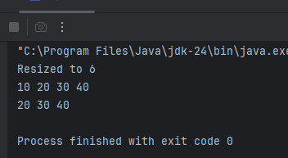
Q.no:2b
class LinkedListQueue {
class Node {
int data;
Node next;
Node(int data) { this.data = data; }
}
Node front, rear;
void enqueue(int data) {
Node n = new Node(data);
if (rear == null) front = rear = n;
else {
rear.next = n;
rear = n;
}
}
int dequeue() {
if (front == null) return -1;
int val = front.data;
front = front.next;
if (front == null) rear = null;
return val;
}
}
public class Main {
public static void main(String[] args) {
LinkedListQueue q = new LinkedListQueue();
q.enqueue(10);
q.enqueue(20);
q.enqueue(30);
System.out.println(q.dequeue());
}
}

Output:
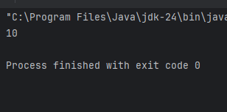

Q.no: 3
class Searching {
static int binarySearchIter(int[] arr, int key) {
int l = 0, r = arr.length - 1;
while (l <= r) {
int m = (l + r) / 2;
if (arr[m] == key) return m;
if (arr[m] < key) l = m + 1;
else r = m - 1;
}
return -1;
}
static int linearSearchRec(int[] arr, int i, int key) {
if (i == arr.length) return -1;
if (arr[i] == key) return i;
return linearSearchRec(arr, i + 1, key);
}
}

public class Main {
public static void main(String[] args) {
int[] arr = {3, 8, 12, 20, 25, 30};
System.out.println(Searching.binarySearchIter(arr, 20));
System.out.println(Searching.linearSearchRec(arr, 0, 12));
}
}

Output:
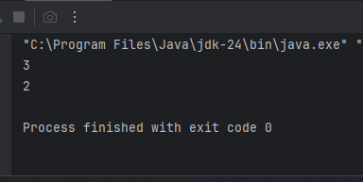
Q.no:5
class Sorting {
static void bubbleSort(int[] arr) {
for (int i = 0; i < arr.length; i++)
for (int j = 0; j < arr.length - 1; j++)
if (arr[j] > arr[j + 1]) {
int t = arr[j];
arr[j] = arr[j + 1];
arr[j + 1] = t;
}
}
}
public class Main {
public static void main(String[] args) {
int[] arr = {5, 1, 4, 2, 8};
Sorting.bubbleSort(arr);
for (int x : arr)
System.out.print(x + " ");
}
}

Output:
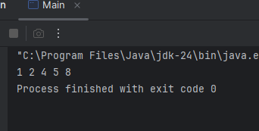

Q.no: 4
class Recursion {
static int factorial(int n) {
if (n == 0) return 1;
return n * factorial(n - 1);
}
static int fibonacci(int n) {
if (n <= 1) return n;
return fibonacci(n - 1) + fibonacci(n - 2);
}
}

public class Main {
public static void main(String[] args) {
System.out.println(Recursion.factorial(5));
System.out.println(Recursion.fibonacci(6));
}
}

Output:
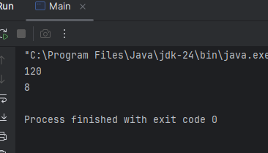

Q.no:6
class BST {
class Node {
int data;
Node left, right;
Node(int d) { data = d; }
}
Node root;
Node insert(Node r, int d) {
if (r == null) return new Node(d);
if (d < r.data) r.left = insert(r.left, d);
else r.right = insert(r.right, d);
return r;
}
void inorder(Node r) {
if (r != null) {
inorder(r.left);
System.out.print(r.data + " ");
inorder(r.right);
}
}
}
public class Main {
public static void main(String[] args) {
BST tree = new BST();
tree.root = tree.insert(tree.root, 50);
tree.insert(tree.root, 30);
tree.insert(tree.root, 70);
tree.insert(tree.root, 20);
tree.insert(tree.root, 40);
tree.inorder(tree.root);
}
}

Output:
